Chapter 1
Introduction
1.1 Mathematical modelling of bacterial resistance to multiple antibiotics and immune system response
1.1.1 Background and Motivation
Bacterial infections have historically been among the leading causes of morbidity and mortality worldwide. The discovery of antibiotics transformed once fatal infections into treatable conditions. However the widespread use of antibiotics has led to the emergence of resistant bacterial strains, which now pose a serious threat to global public health.
Antibiotic resistance occurs when bacteria evolve mechanisms that allow them to survive exposure to drugs designed to kill or inhibit them.
Mathematical modelling offers a powerful approach to studying resistance dynamics. By translating biological interactions into equations, models allow researchers to analyze system behavior, identify critical parameters, and evaluate treatment strategies in a controlled and reproducible way. This project applies such an approach, using a system of ordinary differential equations to model the interaction between sensitive bacteria, resistant bacteria, immune cells, and multiple antibiotics within a single host.
1.1.2 Problem Statement
Despite decades of research, bacterial resistance to antibiotics continues to rise at an alarming rate. Clinical treatment decisions such as which antibiotics to use, at what dose, and for how long are often made without a full quantitative understanding of how resistance develops and how the immune system interacts with both the bacteria and the drugs. Most existing mathematical models either ignore the immune response entirely or treat it as a constant background effect, which fails to capture the dynamic and adaptive nature of host immunity.
Furthermore, the majority of models focus on either the spread of resistance across a population or the pharmacokinetics of a single antibiotic, rarely combining multiple antibiotics with a dynamic immune response in a single within-host framework. This leaves a gap in understanding how these factors interact simultaneously during the course of treatment in an individual patient.
This project addresses that gap by implementing and analyzing the within-host model, which incorporates sensitive and resistant bacterial populations, a dynamic immune cell population, and the concentrations of multiple antibiotics simultaneously. The central question is: under what conditions does antibiotic treatment succeed in controlling infection, and what role does immune system strength play in determining that outcome?
1.2 Logistic Population Models with Harvesting
1.2.1 Background and Motivation
The study of population dynamics has been a fundamental concern in both ecology and applied mathematics. Understanding how populations grow, stabilize, and decline is essential for managing natural resources, particularly in fisheries where human harvesting directly influences population behavior.
The earliest formal mathematical treatment of population growth was proposed by Malthus in 1798, who described growth as purely exponential. While this captured the basic idea of biological reproduction, it failed to account for environmental limits such as food supply and space. To address this, Verhulst introduced the logistic growth model in 1838, incorporating the concept of carrying capacity — the maximum population size an environment can sustainably support. The logistic model became the foundation for much of modern population ecology.
In fishery management, the logistic model was further developed to include harvesting — the deliberate removal of individuals from the population. Two major strategies have been widely studied: constant harvesting, where a fixed number of fish are removed per unit time, and periodic harvesting, which reflects the seasonal nature of real fishing activity where grounds are opened and closed at regular intervals.
These mathematical models, expressed as ordinary differential equations, allow researchers and policymakers to analyze long-term population behavior, identify critical thresholds, and design sustainable harvesting strategies that prevent extinction while maximizing yield.
1.2.2 Problem Statement
Fish populations worldwide are under increasing pressure from commercial and subsistence fishing. According to the Food and Agriculture Organization of the United Nations, a significant portion of global fish stocks are either fully exploited or overexploited, meaning they are being harvested at or beyond their biological limits. When harvesting exceeds the natural capacity of a population to recover, the population enters a state of irreversible decline that can ultimately lead to commercial extinction or even biological extinction of the species.
The central problem addressed in this study is the determination of safe and sustainable harvesting rates for a fish population governed by logistic growth dynamics. Specifically, the study asks: at what harvesting rate does a fish population remain stable, and at what point does harvesting cause the population to collapse? Furthermore, how does the pattern of harvesting — whether constant or periodic — affect the long-term survival and stability of the population?
These questions cannot be answered by intuition or observation alone. A rigorous mathematical framework is needed to model the interaction between natural population growth and human harvesting activity, to identify equilibrium states, to assess their stability, and to determine the critical harvesting threshold known as the Maximum Sustainable Yield (MSY) — the largest harvesting rate that a population can withstand without being driven toward extinction.
1.3 Objectives of the Study
The objectives of this project are as follows:
- To implement the mathematical model numerically using MATLAB.
- To reproduce and verify the analytical equilibrium results through simulation.
- To investigate the effect of immune system strength on treatment outcome.
- To analyze how the fitness cost of resistance influences the persistence of resistant bacteria.
- To evaluate the consequences of early antibiotic termination on bacterial load.
- To compare single antibiotic therapy with combination therapy quantitatively.
- To perform a sensitivity analysis identifying the most critical model parameters.
- To derive and analyze the logistic growth model with constant harvesting and determine its equilibrium points using the quadratic formula.
- To classify the stability of each equilibrium point using linearization and phase portrait analysis.
- To derive the Maximum Sustainable Yield (MSY) and determine the critical harvesting threshold beyond which population extinction occurs.
- To formulate and numerically analyze the logistic growth model with periodic harvesting using the Runge-Kutta method (ode45).
- To compare the long-term behavior of fish populations under constant and periodic harvesting strategies through graphical and numerical simulation.
- To investigate the sensitivity of the model to changes in key parameters including the growth rate k, carrying capacity N, and harvesting rate a.

1.4 Scope and Limitations
This study operates within the following scope and is subject to the following limitations:
Scope:
- This study focuses exclusively on within-host dynamics — the behavior of bacteria, immune cells, and antibiotics within a single infected individual, as well as single-species fish population models governed by the logistic differential equation with two forms of harvesting — constant and periodic.
- The model considers two antibiotics administered simultaneously as combination therapy.
- The study considers a closed fish population with no immigration or emigration.
- Two harvesting models are analyzed: constant harvesting and sinusoidal periodic harvesting.
- Analysis covers both mathematical stability and numerical simulation — over a 90-day treatment period for the bacterial model, and across a defined range of parameter values for the population model.
- MATLAB is used as the primary computational tool for numerical integration and graphical visualization in both models.
Limitations:
- The bacterial model does not capture the spread of infection between individuals or across hospital populations.
- Resistance is assumed to arise solely through spontaneous mutation — horizontal gene transfer and conjugation between bacteria are not modelled.
- The immune response is represented by a single population of cells growing logistically in proportion to bacterial load — innate immunity, antibody responses, and cytokine signaling are not included.
- The population model assumes a single isolated species with no predator-prey interactions or competition from other species.
- Environmental factors such as temperature, disease, pollution, and habitat loss are not incorporated into the population model.
- Both models treat population size as a continuous variable, which is a mathematical idealization — in reality, population size is a discrete whole number.

1.5 MATLAB
MATLAB (Matrix Laboratory) is a high-level programming language and numerical computing environment developed by MathWorks. It is widely used in engineering, mathematics, and science for numerical analysis, matrix computation, algorithm development, and data visualization. Unlike general purpose programming languages, MATLAB is designed specifically for mathematical computation, making it particularly well suited for solving and visualizing systems of differential equations.
In this project MATLAB was used for the following purposes:
- Numerical simulation — the five equation ODE system was implemented as a MATLAB function and solved using the built-in solver ode45, which uses an adaptive Runge-Kutta method to integrate the system.
- Parameter management — all model parameters were organized into a struct object, allowing different simulation cases to be run by changing a single parameter set without modifying the model function
- Stability verification — threshold parameters A, B and C were computed numerically and compared against analytical predictions to verify correctness/
- Visualization — time series plots, phase portraits, and comparison plots were generated using MATLABs built in plotting functions to illustrate system dynamics across all simulation scenarios
- Sensitivity analysis — for loops were used to automate parameter sweeps across multiple values of η, c, and treatment duration, producing the comparison plots.
- Results export — numerical results were organized into formatted tables using MATLAB's table function for inclusion in this report

Chapter 2
Mathematical modelling of bacterial resistance to multiple antibiotics and immune system response
2.1 Overview
2.1.1 Bacterial Infections and Antibiotic Resistance
Bacterial infections remain a leading cause of disease and death globally, affecting millions of people each year across all age groups and healthcare settings. The introduction of penicillin in the 1940s marked the beginning of the antibiotic era, offering effective treatment for infections that had previously carried high mortality. Since then, numerous classes of antibiotics have been developed, each targeting different aspects of bacterial physiology such as cell wall synthesis, protein production, or DNA replication.
However, bacteria are capable of rapid evolutionary adaptation. Resistance to antimicrobial agents is now recognized as both a logical and inevitable consequence of antibiotic use. Each new class of antibiotic introduced into clinical practice has been followed within years, and sometimes months, by the emergence of resistant strains. Resistance mechanisms include enzymatic inactivation of the drug, modification of the drug target, active efflux of the drug from the bacterial cell, and reduced membrane permeability. These mechanisms can arise through spontaneous chromosomal mutations or through the acquisition of resistance genes from other bacteria via horizontal gene transfer.
2.1.2 Multiple Antibiotic Therapy
The use of two or more antibiotics simultaneously, known as combination or multiple antibiotic therapy, has become standard practice for several types of bacterial infection. The rationale for this approach is threefold. First, different antibiotics act on different bacterial targets, so their effects can be additive or synergistic, producing greater bacterial killing than either drug alone. Second, combination therapy reduces the probability of resistance emerging, since a single mutation is unlikely to confer resistance to two drugs with different mechanisms simultaneously. Third, for mixed infections involving multiple bacterial species or strains with different susceptibility profiles, combinations ensure that all components of the infection are covered.
2.1.3 Mathematical Modelling in Infectious Diseases
Mathematical modelling has a long history in the study of infectious diseases. The foundational SIR model, which divides a population into susceptible, infected, and recovered compartments, was introduced in the early twentieth century and remains widely used today for studying epidemic dynamics. More sophisticated extensions of this framework have been developed to account for latent infection, vaccination, age structure, spatial heterogeneity, and many other biological complexities.
2.1.4 Within-Host Models vs Epidemiological Models
Mathematical models of infectious disease can be broadly divided into two categories based on their scale of analysis. Epidemiological models, also called between-host models, describe the spread of infection across a population of individuals. These models are used to predict outbreak trajectories, evaluate vaccination programs, and assess the impact of public health interventions. The SIR model and its variants fall into this category.
Within-host models, by contrast, describe the dynamics of infection inside a single individual. These models track the populations of pathogens, immune cells, and drugs over time within one host and are used to understand the mechanisms of infection progression, immune evasion, and treatment response. Within-host models are particularly relevant for studying antibiotic resistance because resistance develops at the level of individual bacterial cells within a patient, driven by mutation and selection pressure from drugs and immunity.
2.2 Mathematical Model
2.2.1 Model Description and Assumptions
This study examines the within-host dynamics of a bacterial infection in a single patient receiving multiple antibiotic treatment. Unlike epidemiological models such as SIR which track disease spread across a population, this model focuses on what happens inside one individual's body. Specifically, how sensitive bacteria, resistant bacteria, immune cells, and antibiotic concentrations interact and change over time.
The model is built as a system of ordinary differential equations (ODEs) with five state variables: the concentration of antibiotic-sensitive bacteria s(t), antibiotic-resistant bacteria r(t), host immune cells b(t), and the concentrations of two antibiotics — isoniazid INH denoted a₁(t) and pyrazinamide PZA denoted a₂(t). All five variables are normalized, meaning their values fall between 0 and 1, where 1 represents the maximum possible concentration or population size.
2.2.2 State Variables and Parameters
State Variables
The model consists of five state variables, all of which are normalized to dimensionless values in the range [0, 1]. Normalization is achieved by dividing each variable by its respective maximum capacity, which simplifies the mathematical analysis and ensures all variables remain biologically meaningful.
Variable | Meaning | Normalization | Range
s(t) | Population of antibiotic-sensitive bacteria at time t | S(t) divided by carrying capacity T | [0, 1]
r(t) | Population of antibiotic-resistant bacteria at time t | R(t) divided by carrying capacity T | [0, 1]
b(t) | Population of host immune cells at time t | B(t) divided by ωT | [0, 1]
a₁(t) | Concentration of INH (Isoniazid) at time t | A₁(t) divided by δ₁/μ₁ | [0, 1]
a₂(t) | Concentration of PZA (Pyrazinamide) at time t | A₂(t) divided by δ₂/μ₂ | [0, 1]

Where T is the carrying capacity of bacteria, ω is the ratio of immune cell capacity to bacterial capacity, δ_{i} is the supply rate of the i^{th} antibiotic, and μ_{i} is the clearance rate of the i^{th} antibiotic.
Parameters
The model contains the following parameters. Each parameter is strictly positive as required for biological validity.
Parameter | Symbol | Meaning | Unit
Sensitive bacteria growth rate | β_{S} | Maximum per capita growth rate of sensitive bacteria | day⁻¹
Resistant bacteria growth rate | β_{R} | Maximum per capita growth rate of resistant bacteria | day⁻¹
Fitness cost of resistance | c | Fractional reduction in growth rate due to carrying resistance genes | dimensionless
Immune killing rate | η | Rate at which immune cells kill bacteria per unit concentration | day⁻¹
Immune cell growth rate | k | Per capita proliferation rate of immune cells in response to infection | day⁻¹
Mutation rate — INH | α₁ | Rate at which sensitive bacteria mutate to resistant due to INH exposure | day⁻¹
Mutation rate — PZA | α₂ | Rate at which sensitive bacteria mutate to resistant due to PZA exposure | day⁻¹
Antibiotic killing rate — INH | d₁ | Rate at which INH kills sensitive bacteria | day⁻¹
Antibiotic killing rate — PZA | d₂ | Rate at which PZA kills sensitive bacteria | day⁻¹
INH clearance rate | μ₁ | Rate at which INH is cleared from the body | day⁻¹
PZA clearance rate | μ₂ | Rate at which PZA is cleared from the body | day⁻¹

2.2.3 The Ordinary Differential Equation System
The model is governed by a system of five ordinary differential equations describing the time evolution of sensitive bacteria, resistant bacteria, immune cells, and two antibiotic concentrations.
Equation 1 — Sensitive Bacteria
$\frac{ds}{dt}$= β_{S} · s · (1−s−r) − η · s · b − s · [(α₁+d₁) · a₁ + (α₂+d₂) · a₂]
Term | Expression | Meaning
Logistic growth | β_{S} · s · (1−s−r) | Sensitive bacteria grow at rate β_{S} but slow down as total bacteria s+r approach carrying capacity
Immune killing | η · s · b | Immune cells destroy sensitive bacteria at rate η proportional to both populations
Antibiotic effect | s · Σ(α_{i}+d_{i}) · a_{i} | Antibiotics kill sensitive bacteria at rate d_{i} and convert them to resistant through mutation at rate α_{i}

Equation 2 — Resistant Bacteria
$\frac{dr}{dt}$ = β_{R} · r · (1−s−r) − η · r · b + s · [α₁ · a₁ + α₂ · a₂]
Term | Expression | Meaning
Logistic growth | β_{R} · r · (1−s−r) | Resistant bacteria grow at rate β_{R} which is lower than β_{S} due to fitness cost c
Immune killing | η · r · b | Immune cells kill resistant bacteria at the same rate η as sensitive bacteria
Mutation gain | s · Σα_{i} · a_{i} | Sensitive bacteria mutate into resistant ones upon antibiotic exposure — this is a gain for r and a loss for s

Equation 3 — Immune Cells
$\frac{db}{dt}$ = k · b · (1 − b/(s+r))
Term | Expression | Meaning
Logistic growth | k · b · (1 − b/(s+r)) | Immune cells proliferate at rate k with carrying capacity equal to total bacterial load s+r. When bacteria decrease the immune response also contracts. When s+r = 0 immune cells decay at rate k

Equation 4 and 5 — Antibiotic Concentrations
$\frac{da1}{dt}$ = μ₁ · (1 − a₁)
$\frac{da2}{dt}$ = μ₂ · (1 − a₂)
Term | Expression | Meaning
INH dynamics | μ₁ · (1 − a₁) | INH is supplied continuously and cleared at rate μ₁ driving concentration toward normalized steady state of 1
PZA dynamics | μ₂ · (1 − a₂) | Same structure as INH with its own clearance rate μ₂

Complete System
$\frac{ds}{dt}$ = β_{S} · s · (1−s−r) − η · s · b − s · [(α₁+d₁) · a₁ + (α₂+d₂) · a₂]
$\frac{dr}{dt}$ = β_{R} · r · (1−s−r) − η · r · b + s · [α₁ · a₁ + α₂ · a₂]
$\frac{db}{dt}$ = k · b · (1 − b/(s+r))
$\frac{da1}{dt}$ = μ₁ · (1 − a₁)
$\frac{da2}{dt}$ = μ₂ · (1 − a₂)
Biological Constraints
The following constraints must hold at all times for the system to remain biologically valid:
Constraint | Meaning
s(t) ≥ 0 | Sensitive bacteria cannot be negative
r(t) ≥ 0 | Resistant bacteria cannot be negative
0 ≤ b(t) ≤ s+r | Immune cells are bounded by bacterial load
0 ≤ a_{i}(t) ≤ 1 | Antibiotic concentrations are normalized
s(t) + r(t) ≤ 1 | Total bacteria cannot exceed carrying capacity

2.2.4 Normalization of Variables
The original system before normalization is:
$\frac{dS}{dt}$ = β_{S} · S · (1 − (S+R)/T) − λ · S · B − S · Σ ᾱ_{i} · A_{i} − S · Σ d̄_{i} · A_{i}
$\frac{dR}{dt}$ = β_{R} · R · (1 − (S+R)/T) − λ · R · B + S · Σ ᾱ_{i} · A_{i}
$\frac{dB}{dt}$= k · B · (1 − B/(ω(S+R)))
$\frac{dA_{i}}{dt}$= δ_{i} − μ_{i} · A_{i} for i = 1, 2
Substitution Step
We introduce the following normalized variables:
s(t) = $\frac{S(t)}{T}$ , r(t) = $\frac{R(t)}{T}$ , b(t) =$\frac{B(t)}{ωT}$ , a_{i}(t) = $\frac{ A_{i}(t) }{ δ_{i}/μ_{i} }$
With the new variables, the normalized system is given as:
$\frac{ds}{dt}$= β_{S} · s · (1−s−r) − η · s · b − s · [(α₁+d₁) · a₁ + (α₂+d₂) · a₂]
$\frac{dr}{dt}$ = β_{R} · r · (1−s−r) − η · r · b + s · [α₁ · a₁ + α₂ · a₂]
$\frac{db}{dt}$ = k · b · (1 − b/(s+r))
$\frac{da_{1}}{dt}$ = μ₁ · (1 − a₁)
$\frac{da_{2}}{dt}$ = μ₂ · (1 − a₂)
The normalization step reduces the number of independent parameters by combining them:
New Parameter | Formula | Meaning
η | λ · ω · T | Combined immune killing rate in normalized system
α_{i} | ᾱ_{i} · (δ_{i}/μ_{i}) | Normalized mutation rate for i^{th} antibiotic
d_{i} | d̄_{i} · (δ_{i}/μ_{i}) | Normalized killing rate for i^{th} antibiotic
β_{R} | (1−c) · β_{S} | Resistant growth rate incorporating fitness cost

2.2.5 Threshold Parameters A, B and C
Three threshold parameters are derived from the model parameters. These parameters determine which equilibrium the system converges to and therefore determine the long-term outcome of the infection.
Parameter | Formula | Meaning
A | (β_{S} − Σ (α_{i} + d_{i})) / (β_{S} + η) | Net Survival Ability of Sensitive Bacteria
B | β_{R} / (β_{R} + η) | Net Survival Ability of Resistant Bacteria
C | Σα_{i} / (β_{R} + η) | Mutation Contribution

Written explicitly for two antibiotics:
A = $\frac{β_{S}- \left(α_{1}+d_{1}\right) - (α_{2}+d_{2}) }{β_{S} + η}$
B = $\frac{β_{R}}{β_{R} + η}$
C = $\frac{α_{1} + α_{2}}{ β_{R} + η}$

The Key Threshold Condition
The entire long-term behavior of the system depends on comparing A and B:
Condition | Outcome
A < B | Sensitive bacteria die out. Only resistant bacteria and immune cells persist at equilibrium E2. Antibiotics have failed to prevent resistance dominance.
A > B | Both sensitive and resistant bacteria coexist with immune cells at equilibrium E3. Neither type is eliminated.

A < B → E2 is stable → resistant bacteria dominate
A > B → E3 is stable → coexistence of both types
2.3 Mathematical Analysis
2.3.1 Equilibrium Points
Equilibrium points are found by setting all derivatives equal to zero and solving the resulting algebraic system.
$\frac{ds}{dt}$ = 0
$\frac{dr}{dt}$ = 0
$\frac{db}{dt}$ = 0
$\frac{dai}{dt}$ = 0 for i = 1, 2
From $\frac{dai}{dt}$ = 0
- μ_{i} · (1 − a_{i}) = 0
- a_{i} = 1 for i = 1, 2
All equilibrium points have a₁ = a₂ = 1. Substituting a_{i} = 1 into the remaining three equations reduces the system to:
β_{S}·s·(1−s−r) − η·s·b − s·Σ(α_{i}+d_{i}) = 0 ... (i)
β_{R}·r·(1−s−r) − η·r·b + s·Σα_{i} = 0 ... (ii)
k·b· (1 − b/(s+r)) = 0 ... (iii)
From equation (iii) either:
b = 0 (no immune response) or b = s + r (immune cells at maximum capacity)
Case 1 — When b = 0
Substituting b = 0 into (i) and (ii):
s · [β_{S}·(1−s−r) − Σ(α_{i}+d_{i})] = 0
r · [β_{R}·(1−s−r)] = 0
This gives s = 0 and r = 0
Subcase s = 0, r = 0 → gives E0
Subcase s = 0, r ≠ 0 → from β_{R}·(1−r) = 0 → r = 1 → gives E1
Subcase s ≠ 0, r ≠ 0 → gives a point where s and r have opposite signs which is biologically meaningless. so, its rejected.
Case 2 — When b = s + r
Substituting b = s+r into (i) and (ii):
s · [β_{S}·(1−s−r) − η·(s+r) − Σ(α_{i}+d_{i})] = 0 ... (iv)
r · [β_{R}·(1−s−r) − η·(s+r)] + s·Σα_{i} = 0 ... (v)
Subcase s = 0 → substituting into (v):
r · [β_{R}·(1−r) − η·r] = 0
r · [β_{R} − (β_{R}+η) ·r] = 0
r = β_{R}/(β_{R}+η) = B → gives E2
Subcase s ≠ 0 → from (iv) the bracket equals zero:
β_{S}·(1−s−r) − η·(s+r) − Σ(α_{i}+d_{i}) = 0
(β_{S}+η)·(1−s−r) = β_{S} − Σ(α_{i}+d_{i})
(s+r) = [β_{S} − Σ(α_{i}+d_{i})]/(β_{S}+η) = A = b̄
Substituting back gives s̄ and r̄ → gives E3
Equilibrium | Values | Exists When | Biological Meaning
E0 | (0, 0, 0, 1, 1) | Always | System can always be infection free in theory
E1 | (0, 1, 0, 1, 1) | Always | Full resistant bacteria dominance always possible
E2 | (0, B, B, 1, 1) | Always | Resistant bacteria and immune coexistence always possible
E3 | (s̄, r̄, b̄, 1, 1) | A > B only | Coexistence only when sensitive bacteria are relatively strong

2.3.2 Stability Analysis
The Jacobian Matrix
Stability is determined by linearizing the system around each equilibrium point. This gives the Jacobian matrix J evaluated at each equilibrium:
J = $\left[\begin{matrix}\frac{∂φ_{1}}{∂s} & \frac{∂φ_{1}}{∂r} & \frac{∂φ_{1}}{∂b} & \frac{∂φ_{1}}{∂a_{1}} & \frac{∂φ_{1}}{∂a_{2}} \\ \frac{∂φ_{2}}{∂s} & \frac{∂φ_{2}}{∂r} & \frac{∂φ_{2}}{∂b} & \frac{∂φ_{2}}{∂a_{1}} & \frac{∂φ_{2}}{∂a_{2}} \\ \frac{∂φ_{3}}{∂s} & \frac{∂φ_{3}}{∂r} & \frac{∂φ_{3}}{∂b} & \frac{∂φ_{3}}{∂a_{1}} & \frac{∂φ_{3}}{∂a_{2}} \\ \frac{∂φ_{4}}{∂s} & \frac{∂φ_{4}}{∂r} & \frac{∂φ_{4}}{∂b} & \frac{∂φ_{4}}{∂a_{1}} & \frac{∂φ_{4}}{∂a_{2}} \\ \frac{∂φ_{5}}{∂s} & \frac{∂φ_{5}}{∂r} & \frac{∂φ_{5}}{∂b} & \frac{∂φ_{5}}{∂a_{1}} & \frac{∂φ_{5}}{∂a_{2}}\end{matrix}\right]$
Where φ₁...φ₅ are the right-hand sides of the five ODEs. Evaluated explicitly:
J= $\left[\begin{matrix}βs-2βs .s-βs.r-ηb-Σ\left(α_{i}+d_{i}\right)a_{i} & -βs.s & -ηs & -s(α_{1}+d_{1}) & -s(α_{2}+d_{2}) \\ -β_{R}r+Σα_{i}a_{i} & β_{R}-β_{R}.s-2β_{R}.r-ηb & -ηr & sα_{1} & sα_{2} \\ kb²/(s+r)² & kb²/(s+r)² & k-2kb/(s+r) & 0 & 0 \\ 0 & 0 & -μ_{1} & -μ_{1} & 0 \\ 0 & 0 & 0 & 0 & -μ_{2}\end{matrix}\right]$
The eigenvalues λ of J at each equilibrium determine stability:
All eigenvalues have negative real parts → equilibrium is Stable
Any eigenvalue has positive real part → equilibrium is unstable
Routh-Hurwitz Criteria
For a 5×5 Jacobian, finding eigenvalues directly requires solving a degree-5 polynomial — which has no general closed form solution. The Routh-Hurwitz criteria allow us to determine whether all roots have negative real parts without solving for the roots explicitly.
The Criteria
Given characteristic polynomial:
P(λ) = λⁿ + a₁λⁿ⁻¹ + a₂λⁿ⁻² + ... + an = 0
All roots have negative real parts if and only if all Hurwitz determinants are positive.
For n = 2:
Conditions: a₁ > 0 and a₂ > 0
For n = 3:
Conditions: a₁ > 0 and a₃ > 0 and a₁·a₂ > a₃
Stability of E0
λ₁ = β_{S} − Σ(α_{i}+d_{i}) (can be positive)
λ₂ = β_{R} > 0 (always positive)
Since λ₂ = β_{R} is always positive by definition of parameters, E0 is always unstable. The infection free state cannot be maintained.
Stability of E1
λ₁ = −Σ(α_{i}+d_{i}) < 0
λ₂ = −β_{R} < 0
λ₃ = k > 0 (always positive)
Since λ₃ = k is always positive, E1 is always unstable. Pure resistant bacteria without any immune response cannot be maintained.
Stability of E2
Substituting E2 = (0, B, B, 1, 1) into J
The eigenvalues from the last two rows are immediately:
λ₄ = −μ₁ < 0
λ₅ = −μ₂ < 0
These are always stable. The remaining three eigenvalues come from the block matrix:
JB(E2) = $\left[\begin{matrix}β_{S}(1-B) - η·B - Σ(α_{i}+d_{i}) & 0 & 0 \\ -β_{R}·B + Σα_{i} & -β_{R}·B - η·B & 0 \\ k & k & -k\end{matrix}\right]$
The characteristic equation factors as:
[β_{S}(1−B) − ηB − Σ(α_{i}+d_{i}) − λ] · [λ² + λ (k + β_{R}·B) + k·β_{R}·B] = 0
This gives:
λ_{2,1} = β_{S}(1−B) − ηB − Σ(α_{i}+d_{i})
= (β_{S} + η) · (A − B)
And λ_{2,2} and λ_{2,3} from:
λ² + (k + β_{R}·B). λ + k·β_{R}·B = 0
Applying Routh-Hurwitz with n=2:
a₁ = k + β_{R}·B > 0 (all parameters positive)
a₂ = k·β_{R}·B > 0 (all parameters positive)
So λ_{2,2} and λ_{2,3} always have negative real parts.
The only condition remaining is the sign of λ_{2,1}:
λ_{2,1} = (β_{S} + η) (A − B)
A < B → A − B < 0 → λ_{2,1} < 0 → E2 is stable
A > B → A − B > 0 → λ_{2,1} > 0 → E2 is unstable
Therefore, E2 is stable if and only if A < B
Stability of E3
Substituting E3 = (s̄, r̄, b̄, 1, 1) into J
Again, the last two eigenvalues are:
λ₄ = −μ₁ < 0
λ₅ = −μ₂ < 0
The remaining three eigenvalues come from the block matrix:
JB(E3) = $\left[\begin{matrix}-β_{S}·s̄ & -βs·s̄ & -η·s̄ \\ -β_{R}·r̄ + Σα_{i} & β_{R}(1-b̄) - η·b̄ - β_{R}·r̄ & -η·r̄ \\ k & k & -k\end{matrix}\right]$
The characteristic equation is:
λ³ + a₁·λ² + a₂·λ + a₃ = 0
Where:
a₁ = s̄·r̄·Σα_{i} + β_{R}·r̄ + β_{S}·s̄ + k
a₂ = k (s̄·r̄·Σα_{i} + β_{R}·r̄ + β_{S}·s̄) + b̄·η·k + β_{S}·b̄·s̄·r̄·Σα_{i}
a₃ = k·η·b̄·s̄·r̄·Σα_{i} + k·β_{S}·b̄·s̄·r̄·Σα_{i}
Applying Routh-Hurwitz with n=3:
a₁ > 0 (all terms positive since s̄, r̄, b̄ > 0 when A > B)
a₃ > 0 (all terms positive)
a₁·a₂ > a₃
All three Routh-Hurwitz conditions are satisfied whenever E3 exists, that is whenever A > B.
Therefore, E3 is stable if and only if A > B.
Summary Table
Equilibrium | Eigenvalue Signs | Stability Condition
E0 | At least one positive | Always unstable
E1 | At least one positive | Always unstable
E2 | All negative when A < B | A < B
E3 | All negative when A > B | A > B

Biological Interpretation of Each Equilibrium
Equilibrium | Biological Meaning
E0 | Infection free state. Theoretically possible but always unstable — any small bacterial introduction will grow and push the system away from this point.
E1 | Resistant bacteria completely dominate with no immune response. Always unstable — any immune activation will disturb this state.
E2 | Sensitive bacteria are eliminated by antibiotics. Only resistant bacteria remain, held in balance by the immune system. This is the worst clinical outcome — resistance has won.
E3 | Both sensitive and resistant bacteria coexist with active immune response. Neither type is fully eliminated. Antibiotics alone are insufficient to clear the infection.
2.4 Results and Discussion
2.4.1 Parameter Values Used
All parameter values used in the numerical simulations are listed below.

Biological Parameters
Symbol | Description | Value | Unit
β_{S} | Growth rate of sensitive bacteria | 0.8 | day⁻¹
β_{R} | Growth rate of resistant bacteria | 0.4 | day⁻¹
c | Fitness cost of resistance | 0.5 | dimensionless
η | Immune killing rate | 0.3 | day⁻¹
k | Immune cell proliferation rate | 0.6 | day⁻¹
ω | Ratio of immune cell capacity to bacterial capacity | 1 | dimensionless
T | Carrying capacity of bacteria | 10⁹ | cells

Antibiotic Parameters — Case I (A < B)
Symbol | Description | Value | Unit
α₁ | Mutation rate due to INH | 0.02 | day⁻¹
d₁ | Killing rate of sensitive bacteria by INH | 0.15 | day⁻¹
μ₁ | Clearance rate of INH | 0.06 | day⁻¹
α₂ | Mutation rate due to PZA | 0.06 | day⁻¹
d₂ | Killing rate of sensitive bacteria by PZA | 0.35 | day⁻¹
μ₂ | Clearance rate of PZA | 0.03 | day⁻¹

Antibiotic Parameters — Case II (A > B)
Symbol | Description | Value | Unit
β_{R} | Growth rate of resistant bacteria | 0.1 | day⁻¹
η | Immune killing rate | 0.05 | day⁻¹
α₁ | Mutation rate due to INH | 0.06 | day⁻¹
d₁ | Killing rate of sensitive bacteria by INH | 0.30 | day⁻¹
α₂ | Mutation rate due to PZA | 0.02 | day⁻¹
d₂ | Killing rate of sensitive bacteria by PZA | 0.05 | day⁻¹
μ₁ | Clearance rate of INH | 0.06 | day⁻¹
μ₂ | Clearance rate of PZA | 0.03 | day⁻¹

Initial Conditions
Variable | Description | Value | Justification
s(0) | Initial sensitive bacteria | 0.80 | Heavy bacterial load at start of treatment
r(0) | Initial resistant bacteria | 0.05 | Small resistant population already present
b(0) | Initial immune cells | 0.05 | Weak immune response at start
a₁(0) | Initial INH concentration | 0.05 | Antibiotic just administered
a₂(0) | Initial PZA concentration | 0.02 | Antibiotic just administered

2.4.2 Threshold Values A, B and C
Computed Values for Both Cases
Parameter | Formula | Case I | Case II
A | (β_{S} − Σ(α_{i}+d_{i})) / (β_{S}+η) | 0.2000 | 0.3364
B | β_{R} / (β_{R}+η) | 0.5714 | 0.2500
C | Σα_{i} / (β_{R}+η) | 0.1143 | 0.0267
Condition | — | A < B | A > B
Stable Equilibrium | — | E2 | E3

In Case I where A < B, the antibiotics and immune system together are strong enough to eliminate sensitive bacteria completely. However resistant bacteria survive because they are unaffected by antibiotics and can only be controlled by the immune system. The system converges to E2 where only resistant bacteria and immune cells coexist at equilibrium. This represents the clinically unfavorable outcome where antibiotic resistance has effectively won.
In Case II where A > B, the antibiotics are too weak relative to the growth advantage of sensitive bacteria, or the resistant bacteria have a very high fitness cost making them slow to grow. Neither bacterial type is fully eliminated and the system converges to E3 where sensitive bacteria, resistant bacteria, and immune cells all coexist at a stable positive equilibrium.

2.4.3 Case I Results — A < B
All simulations in this section use the Case I parameters where A = 0.2000 and B = 0.5714, giving the condition A < B. The system is therefore expected to converge to equilibrium E2 = (0, 0.5714, 0.5714, 1, 1).
The following plot shows the time evolution of all five state variables under Case I parameters where A = 0.2000 < B = 0.5714.
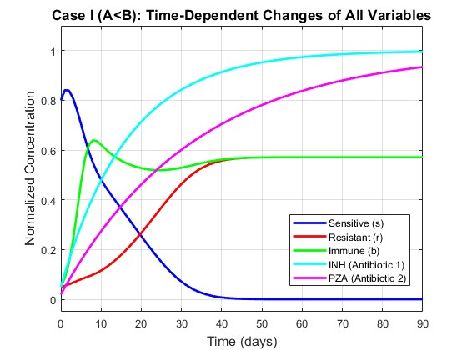
Fig: 2.1 All 5 Variables Over Time (A<B)
The plot shows Sensitive bacteria steadily decline and reach zero by around day 60, wiped out by antibiotics and the immune system. Resistant bacteria survive and stabilize at a low level. Immune cells rise and settle at the same level as resistant bacteria. Both antibiotics quickly reach their maximum concentration and stay there. Overall, the system settles at equilibrium E₂ exactly as the math predicted. The immune cell spike visible in the first 5 days reflects rapid proliferation in response to the high initial bacterial load.

The following plot isolates the relationship between total bacterial load and immune cell population over time.

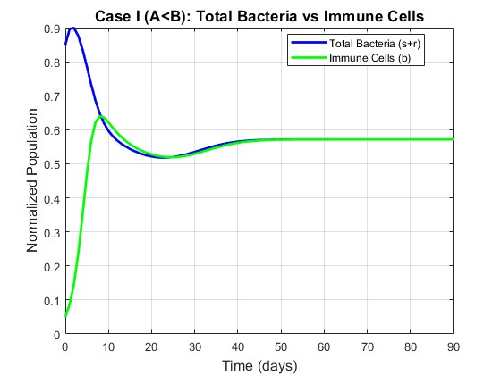
Fig: 2.2 Total Bacteria vs Immune Cells

Fig: 2.2 — Total Bacteria vs Immune Cells Shows that the immune system tracks and matches the bacterial load over time. By day 90 both curves meet at the same value, confirming that the immune system brings the infection under control — not eliminated, but held in a stable balance.

The following plot shows the pharmacokinetic behavior of both antibiotics over the 200-day treatment period.

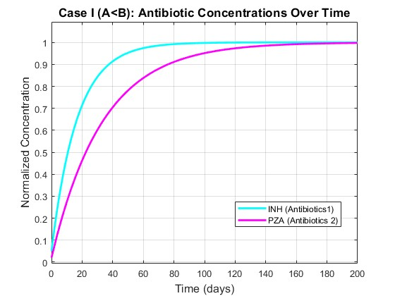
Fig: 2.3 Antibiotic Concentrations

Fig: 2.3 — Antibiotic Concentrations shows Both drugs rise quickly and plateau within the first 30 days. INH stabilizes faster than PZA due to its higher clearance rate. After that, concentrations stay constant for the rest of the treatment.

The following phase Plot shows the trajectory of sensitive bacteria s against resistant bacteria r over the 90-day period under Case I conditions.

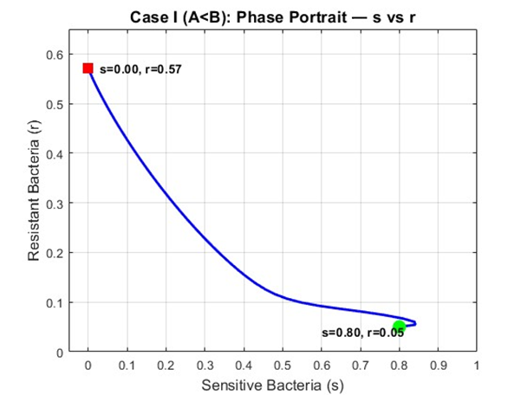
Fig: 2.4 Phase Portrait (s vs r)

The trajectory moves from the initial condition at s=0.80, r=0.05 toward the E2 equilibrium at s=0, r=0.5714. By day 90 sensitive bacteria have reached zero and resistant bacteria have stabilized at 0.5714, confirming complete convergence to E2. Comparing this with the Case II phase portrait shows the difference — in Case I the trajectory terminates on the r-axis where s=0, while in Case II the trajectory terminates at a positive s value confirming coexistence.

Numerical Results — Case I (A < B)
The following table records exact numerical values at 10-day intervals confirming convergence to E2 = (0, 0.5714, 0.5714, 1, 1).

Time (days) | Sensitive (s) | Resistant (r) | Total (s+r) | Immune Cells (b) | INH (a₁) | PZA (a₂)
0 | 0.8000 | 0.0500 | 0.8500 | 0.0500 | 0.0500 | 0.0200
10 | 0.4812 | 0.1157 | 0.5969 | 0.6219 | 0.4786 | 0.2740
20 | 0.2542 | 0.2671 | 0.5213 | 0.5275 | 0.7139 | 0.4622
30 | 0.0708 | 0.4641 | 0.5349 | 0.5294 | 0.8430 | 0.6016
40 | 0.0075 | 0.5577 | 0.5651 | 0.5617 | 0.9138 | 0.7048
50 | 0.0004 | 0.5706 | 0.5710 | 0.5707 | 0.9527 | 0.7813
60 | 0.0000 | 0.5714 | 0.5714 | 0.5714 | 0.9740 | 0.8380
70 | 0.0000 | 0.5714 | 0.5714 | 0.5714 | 0.9858 | 0.8800
80 | 0.0000 | 0.5714 | 0.5714 | 0.5714 | 0.9922 | 0.9111
90 | 0.0000 | 0.5714 | 0.5714 | 0.5714 | 0.9957 | 0.9341

Table: 2.1 Numerical Results — Case I (A < B)

Sensitive bacteria fall to zero by day 60 and remain there. Resistant bacteria and immune cells both stabilize at 0.5714 by day 90, numerically confirming the theoretical equilibrium E2.

2.4.4 Case II Results — A > B
All simulations in this section use the Case II parameters where A = 0.3364 and B = 0.2500, giving the condition A > B. The system is therefore expected to converge to equilibrium E₃ = (0.1015, 0.2350, 0.3364, 1, 1)
The following plot shows the time evolution of all five state variables under Case II parameters where A = 0.3364 > B = 0.2500.

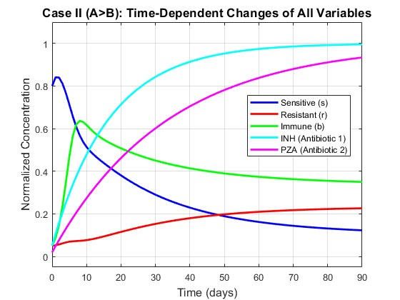
Fig: 2.5 All 5 Variables Over Time (A>B)

Fig: 2.5 — All 5 Variables Over Time shows Unlike Case I, sensitive bacteria do not go to zero — they decline but stabilize at a positive value. Resistant bacteria also persist. Both coexist alongside immune cells at a stable equilibrium, confirming convergence to E₃ as predicted by the model.

The following phase portrait shows the trajectory of sensitive bacteria s against resistant bacteria r over the 90-day period.

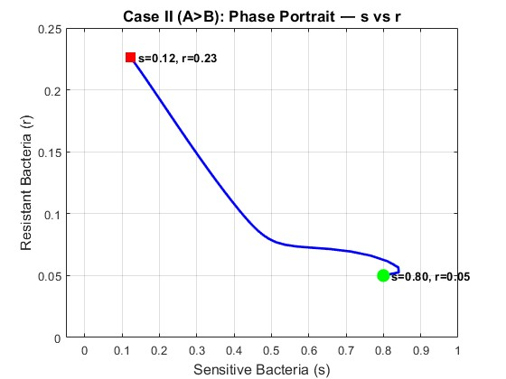
Fig: 2.6 Phase Portrait (s vs r)

Fig: 2.6 — Phase Portrait (s vs r) Shows the trajectory of the system from start (green) to end (red). The path curves toward E₃ where both s and r are positive, visually confirming that neither bacterial strain is eliminated under these conditions.

The following plot shows all three biological populations together to demonstrate coexistence under Case II conditions.

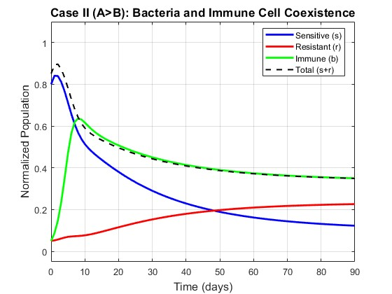
Fig: 2.7 Bacteria and Immune Coexistence

Fig: 2.7 — Bacteria and Immune Coexistence shows All three populations — sensitive, resistant, and immune cells — stabilize at positive values by day 90. The immune system cannot fully clear the infection; instead, a three-way balance is reached. This reflects the biological scenario where antibiotics and immunity together are insufficient to eliminate the bacteria.
Unlike Case I where immune cells converged to the same values resistant bacteria, in Case II immune cells track the total bacterial load s+r which remains higher due to the persistence of sensitive bacteria alongside resistant ones.

Numerical Results — Case II (A > B)
The following table records exact numerical values at 20-day intervals showing convergence toward E3.
Time (days) | Sensitive (s) | Resistant (r) | Total (s+r) | Immune Cells (b) | INH (a₁) | PZA (a₂)
0 | 0.8000 | 0.0500 | 0.8500 | 0.0500 | 0.0500 | 0.0200
20 | 0.3805 | 0.1155 | 0.4960 | 0.5075 | 0.7139 | 0.4622
40 | 0.2293 | 0.1798 | 0.4091 | 0.4139 | 0.9138 | 0.7048
60 | 0.1622 | 0.2096 | 0.3718 | 0.3740 | 0.9740 | 0.8380
80 | 0.1315 | 0.2228 | 0.3543 | 0.3554 | 0.9922 | 0.9111
100 | 0.1169 | 0.2288 | 0.3457 | 0.3462 | 0.9976 | 0.9512
120 | 0.1095 | 0.2318 | 0.3413 | 0.3416 | 0.9993 | 0.9732
140 | 0.1058 | 0.2333 | 0.3390 | 0.3392 | 0.9998 | 0.9853
160 | 0.1038 | 0.2340 | 0.3378 | 0.3379 | 0.9999 | 0.9919
180 | 0.1027 | 0.2344 | 0.3371 | 0.3372 | 1.0000 | 0.9956
200 | 0.1021 | 0.2347 | 0.3368 | 0.3368 | 1.0000 | 0.9976
220 | 0.1018 | 0.2348 | 0.3366 | 0.3366 | 1.0000 | 0.9987
240 | 0.1016 | 0.2348 | 0.3365 | 0.3365 | 1.0000 | 0.9993
Table: 2.2 Numerical Results — Case II (A > B)
The table records numerical values at 20-day intervals up to day 240. By day 220 the system has effectively converged with changes between consecutive time points less than 0.0002. All three populations s, r and b remain positive throughout — s stabilizes at 0.1016, r at 0.2348, and b at 0.3365 which numerically confirming the theoretical equilibrium E3 = (0.1015, 0.2350, 0.3364, 1, 1) Unlike Case I where sensitive bacteria reached zero, in Case II all populations coexist at positive values as predicted by the A > B threshold condition.

2.4.5 Effect of Immune System Strength
To examine how immune system strength affects the outcome, the immune killing rate η was varied across four values (0.1, 0.3, 0.6, 1.0) while all other parameters were held constant at Case I values.

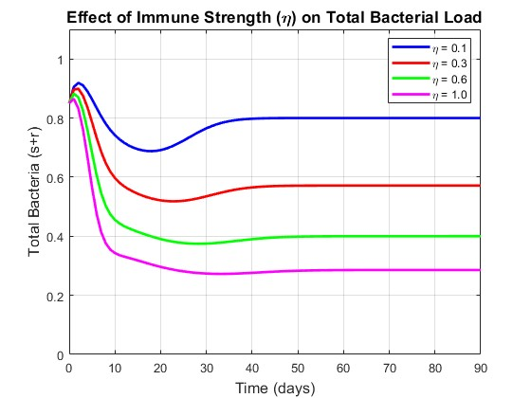
Fig: 2.8 Effect of Immune Strength on Total Bacterial load
The plot shows total bacterial load over 90 days for four values of η (0.1, 0.3, 0.6, 1.0), where η represents the rate at which immune cells kill bacteria.
When η is low (0.1), the immune system is weak and bacterial load remains high throughout the treatment. As η increases, bacteria are cleared faster and settle at a lower equilibrium. At η = 1.0, the bacterial burden is reduced most aggressively. This confirms what the model predicts — a stronger immune response directly lowers the equilibrium bacterial load. In clinical terms, immunocompromised patients (low η) will carry a higher bacterial burden even under the same antibiotic treatment, making recovery harder.

2.4.6 Effect of Fitness Cost
The fitness cost parameter c was varied across four values (0.1, 0.3, 0.5, 0.9) to show its effect on the resistant bacterial population. All other parameters were held at Case I values.

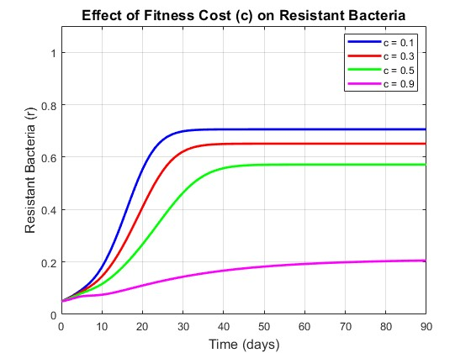
Fig: 2.9 Effect of Fitness Cost in Resistance Bacteria
The plot shows how the resistant bacterial population evolves over 90 days for four values of fitness cost c (0.1, 0.3, 0.5, 0.9), where c directly reduces the growth rate of resistant bacteria as β_R = (1−c) β_S.
When c is small (0.1), resistant bacteria carry almost no fitness penalty and grow rapidly to a high equilibrium level. As c increases, resistant bacteria grow more slowly and stabilize at progressively lower levels. At c = 0.9, the fitness cost is severe and resistant bacteria remain at a very low level throughout. This shows that the biological cost of resistance is a natural limiting factor — the higher the cost, the less dominant resistant strains become. In clinical terms, this suggests that reducing antibiotic pressure can allow high-cost resistant strains to die out naturally over time.
2.4.7 Early Antibiotic Termination
To model the clinical scenario of incomplete treatment, antibiotic supply was set to zero after day 30, day 60, and kept active for the full 90 day course respectively.

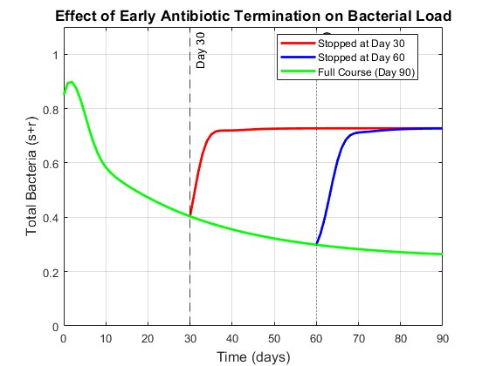
Fig: 2.10 Effect of Antibiotic Termination on Total Bacterial load
The plot compares total bacterial load when antibiotics are stopped at day 30, day 60, or completed for the full 90-day course.
When treatment is stopped at day 30, bacteria rebound sharply after the antibiotics are removed. The immune system alone is insufficient to control the infection and bacterial load climbs back toward high levels. Stopping at day 60 shows a partial rebound — bacteria had been suppressed further before treatment ended, so the rise is slower and settles at a higher level than the full course but lower than the day 30 case. Completing the full 90-day course produces the lowest final bacterial burden, with the system held at the E₂ equilibrium throughout. This result has a direct clinical message — incomplete antibiotic courses not only fail to clear the infection but actively create conditions for bacterial resurgence, and in practice, for resistance amplification.
2.4.8 Single vs Combination Therapy
The following plot shows sensitive bacteria s only, which more clearly demonstrates the difference in clearance speed between the three treatment strategies.
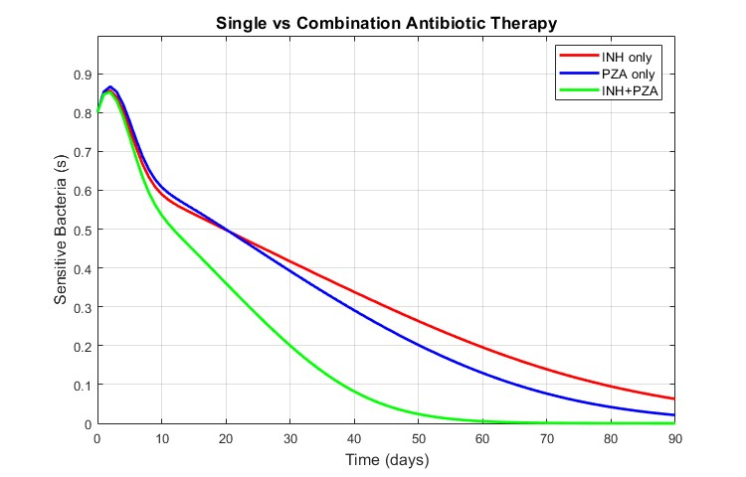
Fig: 2.11 Effect of Single vs Combination Therapy on sensitive bacteria
The plot shows the evolution of sensitive bacteria s over 90 days under three treatment strategies. All three treatments successfully reduce sensitive bacteria throughout the treatment period, but at noticeably different rates. INH alone shows the slowest clearance, declining gradually and reaching approximately 0.08 by day 90 without fully eliminating the sensitive population. PZA alone performs moderately better, clearing sensitive bacteria more rapidly and approaching near zero by day 90. Combination therapy achieves the fastest clearance of all three strategies, suppressing sensitive bacteria most aggressively and driving them closest to zero by the end of the 90-day period. This confirms the clear clinical advantage of combination therapy — faster elimination of sensitive bacteria reduces the time window during which mutation to resistance can occur, thereby lowering the long-term risk of resistance dominance.

The following plot compares total bacterial load under three treatment strategies using identical initial conditions.

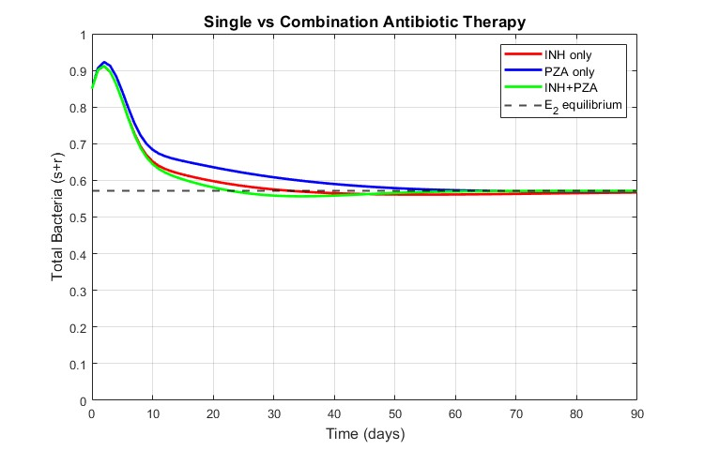
Fig: 2.12 Effect of Single vs Combination Therapy on Total bacteria
The plot compares total bacterial load s+r over 90 days under three treatment strategies: INH alone, PZA alone, and both antibiotics together. All three trajectories converge to the same E2 equilibrium at approximately 0.5714, which is consistent with the theoretical prediction since all three parameter sets satisfy the condition A < B. However, the three strategies differ significantly in their speed of convergence. Combination therapy reaches the equilibrium fastest, followed by PZA alone, with INH alone being the slowest to stabilize. Notably, PZA alone suppresses total bacterial load more effectively than INH alone during the early and middle phases of treatment, despite both single-drug strategies ultimately reaching the same long-run equilibrium. This demonstrates that while all three strategies eventually control the infection to the same theoretical level, combination therapy provides the fastest path to equilibrium and offers the greatest suppression of bacterial load throughout the treatment period.
The following table records the total bacterial load (s+r) at 20-day intervals for all three treatment strategies, confirming convergence to the theoretical E2 equilibrium at 0.5714.
Time (days) | INH only | PZA only | Combination
0 | 0.8500 | 0.8500 | 0.8500
20 | 0.5979 | 0.6359 | 0.5809
40 | 0.5650 | 0.5900 | 0.5585
60 | 0.5615 | 0.5731 | 0.5698
80 | 0.5652 | 0.5703 | 0.5714
100 | 0.5685 | 0.5709 | 0.5714
120 | 0.5702 | 0.5713 | 0.5714
140 | 0.5709 | 0.5714 | 0.5714
160 | 0.5712 | 0.5714 | 0.5714
180 | 0.5714 | 0.5714 | 0.5714
Table 2.3 — Total Bacterial Load (s+r) Under Three Treatment Strategies
All three treatment strategies converge to the same E2 equilibrium value of 0.5714 by day 180, confirming the theoretical prediction. Combination therapy converges fastest, reaching equilibrium by day 80. PZA alone reaches equilibrium by day 140, while INH alone is the slowest, stabilizing at 0.5714 only by day 180. This numerical result reinforces the conclusion that while all three strategies ultimately reach the same long-run equilibrium, combination therapy provides the fastest bacterial suppression throughout the treatment period.

Chapter 3
Logistic Population Models with Harvesting

3.1 Overview
3.1.1 Malthusian Growth Model
The simplest population model was proposed by Thomas Malthus in 1798. It assumes that the rate of population growth is directly proportional to the current population size:
$\frac{dP }{dt}$= kP
where k > 0 is the intrinsic growth rate. The solution to this equation is:
P(t) = P₀ * e^{kt}
This describes unlimited exponential growth. While realistic for small populations with abundant resources, it fails in practice because it predicts that the population grows without bound, which is biologically impossible. This fundamental flaw motivated the development of the logistic growth model.
3.1.2 Logistic Growth Model
To correct the unrealistic assumption of unlimited growth, Pierre François Verhulst introduced the logistic growth model in 1838 by incorporating a carrying capacity N — the maximum population size the environment can sustainably support. The logistic equation is:
$\frac{dP }{dt}$ = kP (1 - $\frac{P}{N}$)
The term (1 - P/N) acts as a braking factor. When P is much smaller than N, the term is close to 1 and growth is nearly exponential. As P approaches N, the term approaches 0 and growth slows. If P exceeds N, the term becomes negative and the population declines back toward N. The analytic solution is:
P(t) = $\frac{N}{1 + \left(\frac{N - P0}{P0}\right) * e^{(-kt)} }$
This produces the characteristic S-shaped (sigmoidal) growth curve observed in many real populations.
3.2 Logistic Growth with Constant Harvesting
3.2.1 Model Formulation
In the constant harvesting model, it is assumed that a fixed number of fish, denoted by a, are removed from the population per unit time regardless of the current population size. Adding this harvesting term to the logistic growth equation gives the following first-order ordinary differential equation:
$\frac{dP}{dt}$ = kP (1 - $\frac{P}{ N}$) - a
where:
b | Description | Unit
P | Size of the fish population at time t | number of fish
t | Time | years or seasons
k | Intrinsic growth rate | per unit time
N | Carrying capacity of the environment | number of fish
a | Constant harvesting rate | fish per unit time

This equation states that the rate of change of the population at any time is equal to the natural logistic growth minus the constant amount removed by harvesting. When a = 0, the equation reduces to the standard logistic model with no harvesting.

3.2.2 Equilibrium Analysis
Equilibrium points are found by setting $\frac{dP}{dt}$ = 0:
kP (1 - $\frac{P}{N}$) - a = 0
Expanding the left-hand side:
kP - $\frac{kP²}{N}$ - a = 0
Multiplying through by -N/k:
P² - NP + $\frac{aN}{k}$ = 0
This is a quadratic equation in P with coefficients:
A = 1, b = -N, c = $\frac{aN}{k}$
Applying the quadratic formula P = (-b ± $\sqrt{(N² - 4aN/k) }$) / 2A:
P = (N ± $\sqrt{(N² - 4aN/k) }$) / 2
This gives two equilibrium points:
P₁ = (N + $\sqrt{(N² - 4aN/k) }$) / 2
P₂ = (N - $\sqrt{(N² - 4aN/k) }$) / 2
The existence of real equilibrium points depends entirely on the discriminant:
D = N² - $\frac{4aN}{k}$

3.2.3 Discriminant Condition
The discriminant D = N² - $\frac{4aN}{k}$ determines the number and nature of equilibrium points. Three cases arise:
Case 1: D > 0 — Two distinct equilibria
Condition: a < kN/4
Two distinct real equilibrium points P₁ and P₂ exist. The population can survive if the initial condition is above P₂.
Case 2: D = 0 — One equilibrium (MSY point)
Condition: a = kN/4
The two equilibria merge into a single point at P* = N/2. This is the critical boundary called the Maximum Sustainable Yield. Any harvesting beyond this point leads to extinction.
Case 3: D < 0 — No real equilibria
Condition: a > kN/4
No real equilibrium points exist. The harvesting rate exceeds what the population can recover from and the population declines to extinction regardless of the initial condition.
3.2.4 Maximum Sustainable Yield
The Maximum Sustainable Yield (MSY) is the largest harvesting rate a that still permits the population to sustain itself indefinitely. It is found by setting the discriminant equal to zero:
D = 0
N² - 4aN/k = 0
Solving for a:
MSY = kN/4
For D=0:
P₁, P₂ = (N + 0) / 2 = N/2
At this harvesting rate the two equilibria merge at:
P* = N/2
This means the MSY is achieved when the population is maintained at exactly half its carrying capacity. For the parameters (k = 0.20, N = 5):
MSY = (0.20 x 5) / 4 = 0.25
Any harvesting rate above 0.25 will drive the population to extinction.
3.2.5 Stability Analysis
To classify the stability of each equilibrium point, the linearization method is applied.
Let:
f(P) = kP (1 - P/N) – a

The derivative with respect to P is:
$\frac{df }{dP}$ = k (1 - 2P/N)

At P₁:
Since P₁ = (N + sqrt(D))/2 is greater than N/2, substituting into the derivative gives:
$\frac{df }{dP}$ = k (1 - 2P₁/N) < 0
Since the eigenvalue is negative, P₁ is a stable equilibrium. Populations near P₁ will return to it after a small disturbance.
At P₂:
Since P₂ = (N - sqrt(D))/2 is less than N/2, substituting into the derivative gives:
$\frac{df }{dP}$= k (1 - 2P₂/N) > 0
Since the eigenvalue is positive, P₂ is an unstable equilibrium. Populations above P₂ recover toward P₁, while populations below P₂ decline to extinction. This result has a critical biological interpretation: P₂ acts as a danger threshold. If the fish population ever falls below P₂ — due to overharvesting, environmental shock, or disease — it will continue to decline and cannot recover on its own.

3.2.6 Parameter Table and Equilibrium Values
Using the parameters k = 0.20 and N = 5, the equilibrium points are computed as:
P₁, P₂ = (5 ± $\sqrt{25 - 20a}$) / 2

Equilibrium Points for Varying Harvesting Rate (k = 0.20, N = 5)
a | Discriminant D | P₁ (stable) | P₂ (unstable) | Status
0.00 | 25.000 | 5.0000 | 0.0000 | Two equilibria
0.21 | 4.000 | 3.5000 | 1.5000 | Two equilibria
0.22 | 3.000 | 3.3660 | 1.6340 | Two equilibria
0.23 | 2.000 | 3.2071 | 1.7929 | Two equilibria
0.24 | 1.000 | 3.0000 | 2.0000 | Two equilibria
0.25 | 0.000 | 2.5000 | 2.5000 | MSY — saddle node
0.26 | -1.000 | — | — | Extinction

Table 3.1: Equilibrium Points for Varying Harvesting Rate
As a increases, P₁ decreases and P₂ increases — the two equilibria move closer together. At a = 0.25 they meet at P* = 2.5. Beyond this point no sustainable equilibrium exists.

3.2.7 Results and Plots
The following figures present the graphical results of the constant harvesting model using the parameters k = 0.20, N = 5, and varying values of the harvesting rate a. Five figures are presented: the equilibrium map, the phase portrait, and three slope field plots corresponding to the three discriminant cases identified in Section 3.2.3.

Equilibrium Map (P₁ and P₂ vs a)

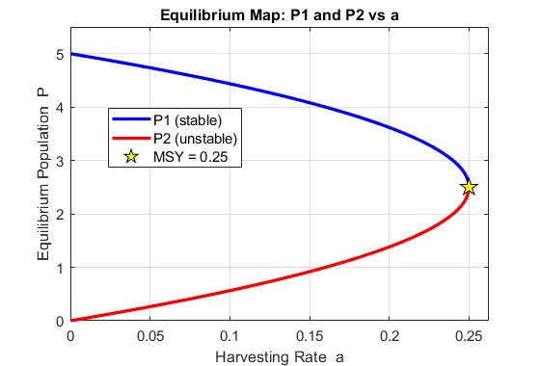
Fig 3.1 — Equilibrium Map (P₁ and P₂ vs a)
The equilibrium map shows both P₁ and P₂ plotted as continuous curves against the harvesting rate a ranging from 0 to the MSY. As a increases from 0, P₁ decreases from N while P₂ increases from 0. The two curves meet at the MSY point (a = 0.25, P = 2.5), forming a characteristic saddle-node bifurcation. Beyond this point both curves become undefined, indicating extinction.

Phase Portrait (dP/dt vs P)
The phase portrait plots dP/dt against P for the constant harvesting equation with a = 0.21. The curve crosses the horizontal axis at P₂ = 1.5 and P₁ = 3.5. Between these two points the curve is positive meaning the population is growing. Outside this interval — below P₂ and above P₁ — the curve is negative meaning the population is declining. The green shaded region indicates the growth zone and the red shaded region indicates the decline zone.

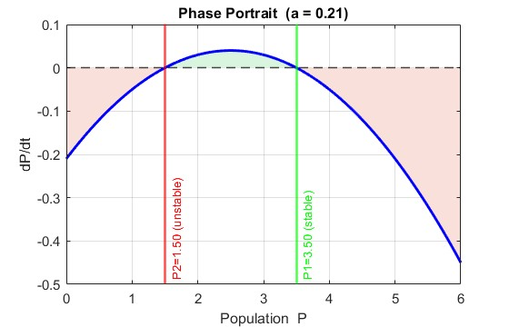
Fig 3.2 — Phase Portrait (dP/dt vs P)
The two zero crossings directly correspond to the unstable equilibrium P₂ = 1.5 and the stable equilibrium P₁ = 3.5. at P₂ the curve crosses from negative to positive going left to right, which corresponds to an unstable equilibrium, while at P₁ the curve crosses from positive to negative, which corresponds to a stable equilibrium.

Slope Field and Trajectories for a < MSY (a = 0.21)
The slope field and solution trajectories for the constant harvesting model when the harvesting rate a = 0.21 is below the MSY of 0.25. Multiple initial conditions are plotted ranging from P0 = 0.5 to P0 = 5.5 to illustrate the behavior of the system from different starting populations.
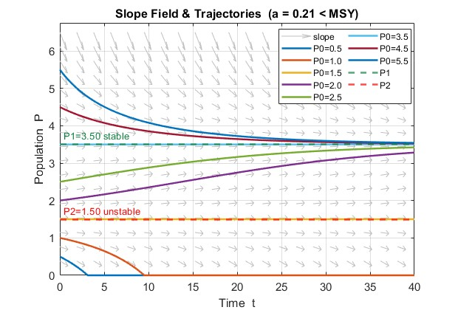
Fig 3.3 — Slope Field and Trajectories for a < MSY (a = 0.21)
The slope field shows arrows that are nearly horizontal near P₁ = 3.5, confirming that it is a stable equilibrium. Near P₂ = 1.5 the arrows diverge — pointing upward above P₂ and downward below P₂ — confirming its unstable nature. All solution curves starting above P₂ = 1.5 converge toward the stable equilibrium P₁ = 3.5 over time regardless of whether they start above or below P₁. Solution curves starting below P₂ = 1.5, specifically P0 = 0.5 and P0 = 1.0, decline monotonically toward zero confirming the danger threshold behavior of P₂.

Slope Field and Trajectories at a = MSY (a = 0.25)
The slope field and solution trajectories when the harvesting rate equals exactly the MSY of 0.25. At this critical value the discriminant D = 0 and the two equilibria merge into a single point at P* = N/2= 2.5.

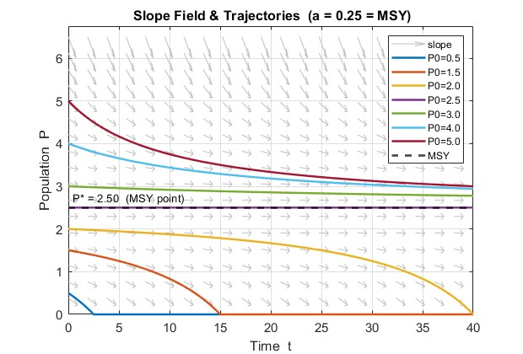
Fig 3.4 — Slope Field and Trajectories at a = MSY (a = 0.25)
The behavior at the MSY is qualitatively different from the a = 0.21 case. Solution curves starting above P* = 2.5 converge very slowly toward P* from above, while solution curves starting below P* = 2.5 decline to extinction. The convergence from above is noticeably slower than in the a = 0.21 case because the merged equilibrium is only marginally stable — the derivative df/dP equals exactly zero at this point making recovery extremely slow. The system is at its most delicate balance and any slight increase in harvesting beyond this point will cause complete collapse.

Slope Field and Trajectories for a > MSY (a = 0.26)
The slope field and solution trajectories when the harvesting rate a = 0.26 exceeds the MSY of 0.25. At this value the discriminant D = -1 and no real equilibria exist.

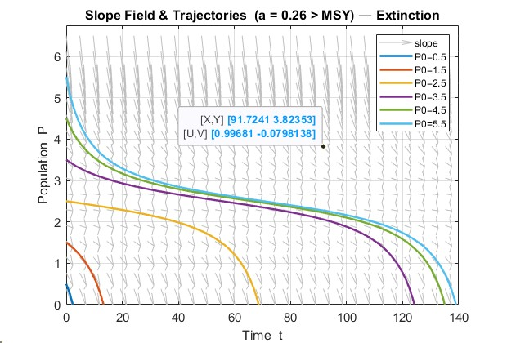
Fig 3.5 — Slope Field and Trajectories for a > MSY (a = 0.26)

When the harvesting rate exceeds the MSY no equilibrium exists. All solution curves regardless of initial condition decline monotonically to zero. This confirms that harvesting beyond the MSY inevitably leads to population extinction.

3.3 Logistic Growth with Periodic Harvesting
3.3.1 Model Formulation
In reality, fishing activity does not occur at a constant rate throughout the year. Fishing grounds are opened and closed according to seasons, weather conditions, and regulatory schedules. To model this more realistic scenario, the constant harvesting term a is replaced by a sinusoidal function that oscillates over time. The resulting periodic harvesting model is:
$\frac{dP}{dt}$ = kP (1 - P/N) - a (1 + sin(bt))
where:
Parameter | Description | Unit
P | Size of the fish population at time t | number of fish
t | Time | years or seasons
k | Intrinsic growth rate | per unit time
N | Carrying capacity of the environment | number of fish
a | Harvesting amplitude — controls intensity of harvesting | fish per unit time
b | Angular frequency — controls how often harvesting cycles occur | radians per unit time

The term a (1 + sin(bt)) represents a harvesting rate that oscillates between 0 and 2a over time. When sin(bt) = 1 the harvesting is at its peak intensity of 2a. When sin(bt) = -1 the harvesting drops to zero, representing a closed fishing season. When sin(bt) = 0 the harvesting equals a, representing the average rate. This structure naturally captures the opening and closing of fishing seasons throughout the year.

3.3.2 Role of Parameter a
The parameter a control the amplitude and average intensity of harvesting. It determines how much fish is removed on average per unit time and how large the seasonal swings are.
When a is small the oscillations are mild and the population recovers sufficiently between fishing seasons. As a increases toward MSY = kN/4 the peak harvesting rate reaches 2a, which can temporarily push the population below its safe threshold. Even with partial recovery during the closed season, repeated exposure to high peak rates causes a net downward trend over time. This is why the effective safe harvesting limit in the periodic model is lower than the MSY derived for the constant model — the oscillations introduce additional stress that constant harvesting does not capture
3.3.3 Role of Parameter b
The parameter b controls the frequency of the harvesting cycle. The period of one complete cycle is:
Period = $\frac{2π}{b}$

Value of b | Period | Biological Meaning
0.5 | 12.57 | Long slow cycles — extended recovery periods
1.0 | 6.28 | Standard seasonal fishing
2.0 | 3.14 | More frequent harvesting — less recovery time
4.0 | 1.57 | Very frequent short seasons

When b is small the harvesting cycles are long and slow. The population experiences long periods of low harvesting during which it can recover substantially before the next peak. When b is large the harvesting cycles are short and rapid. The population is hit repeatedly with peak harvesting before it has time to recover, causing a stronger cumulative downward pressure on the population even if the average harvesting rat a remains the same.

3.3.4 Why No Analytic Solution Exists
The constant harvesting model $\frac{dP}{dt}$= kP (1 - $\frac{P}{N}$) - a is an autonomous ODE because the right-hand side depends only on P and not on time t. This allowed the equation to be solved analytically using separation of variables and partial fractions.
The periodic harvesting model $\frac{dP}{dt}$ = kP (1 - P/N) - a (1 + sin(bt)) is a non-autonomous ODE because the sine term introduces an explicit dependence on time t. This has two important consequences.
First, separation of variables is no longer possible. When attempting to separate the equation: dP / [kP (1 - P/N) - a (1 + sin(bt))] = dt
the left-hand side contains both P and t mixed together through the sine term, making clean separation impossible.
Second, the concept of fixed equilibrium points breaks down. In the autonomous case dP/dt = 0 gave fixed values P₁ and P₂ that did not change with time. In the non-autonomous case setting $\frac{dP}{dt}$= 0 gives: kP (1 - P/N) = a (1 + sin(bt))
The right-hand side changes with every value of t, meaning the equilibrium position itself shifts continuously over time. There are no fixed steady states — only time-varying quasi-equilibria that oscillate with the harvesting cycle.
For these reasons no closed-form analytic solution exists for the periodic harvesting model and the solution must be obtained entirely through numerical methods.

3.3.5 Results and Plots
The following figures present the graphical results of the periodic harvesting model using the parameters k = 0.20, N = 5, and b = 1.0. Four figures are presented for two values of the harvesting rate — a = 0.21 (below MSY) and a = 0.25 (at MSY) — showing both the slope field and solution trajectories for each case. A fifth figure examines the effect of varying the frequency parameter b.
Slope Field for Periodic Harvesting (a = 0.21, b = 1.0)
Unlike the constant harvesting slope field which shows uniform horizontal arrows near the equilibrium, the periodic harvesting slope field shows arrows that vary in direction depending on both P and t. This time-dependent variation is a direct visual consequence of the non-autonomous nature of the equation. The arrows oscillate in direction across time, reflecting the periodic rise and fall of the harvesting rate.
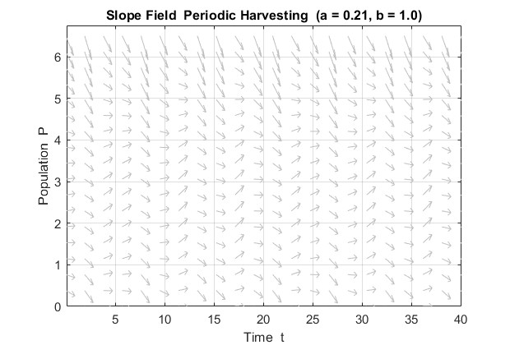
Fig 3.6 — Slope Field for Periodic Harvesting (a = a₁ = 0.21)
In the constant harvesting slope field, the arrows are uniform across time at any given population level P the arrow direction does not change with t. In the periodic harvesting slope field, the arrows change direction periodically across the time axis, showing that the rate of population change depends not only on the current population size but also on the current phase of the harvesting cycle.
Trajectories for Periodic Harvesting (a = 0.21, b = 1.0)
For a = 0.21, which is below the MSY of 0.25, the population trajectories show a characteristic oscillating behavior. Instead of converging smoothly to a fixed equilibrium as in the constant harvesting model, the population rises and falls repeatedly in response to the sinusoidal harvesting cycle. Populations starting above approximately P = 1.5 settle into a sustained oscillation around a mean value below N. Populations starting very low such as P0 = 0.5 and P0 = 1.0 decline toward extinction during the early peak harvesting phase before the closed season can allow sufficient recovery.
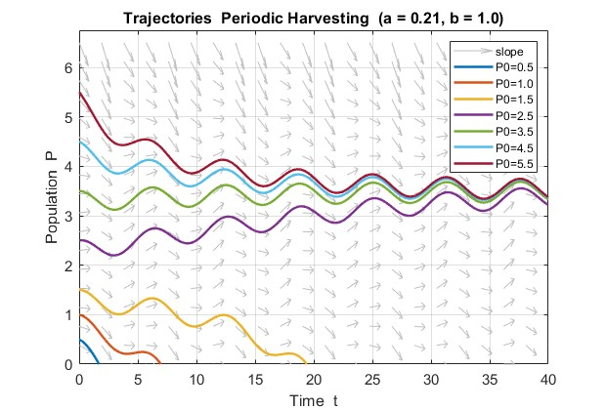
Fig 3.7 — Trajectories for Periodic Harvesting (a = a₁ = 0.21)
The oscillating trajectories confirm that the periodic model produces no fixed steady state. The sustained oscillations observed for higher initial conditions represent the long-term behavior of the system — the population permanently cycles between a peak during the closed season and a trough during the open season.
Slope Field for Periodic Harvesting (a = 0.25, b = 1.0)
At a = 0.25 the slope field shows more aggressively downward-pointing arrows compared to the a = 0.21 case. This reflects the fact that the peak harvesting rate now reaches 2 x 0.25 = 0.50, which is double the MSY. The slope field clearly shows that for most values of P the population is being driven downward during peak harvesting periods.

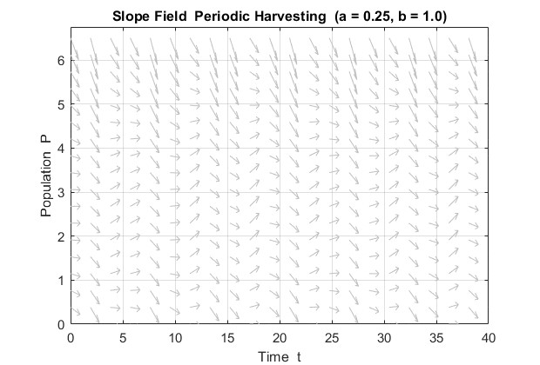
Fig 3.8 — Slope Field for Periodic Harvesting (a = a₂ = 0.25)

Trajectories for Periodic Harvesting (a = 0.25, b = 1.0)
At a = 0.25 the effect of the sine function becomes fully apparent. The trajectories still oscillate but the oscillations are larger in amplitude and the mean population level shows a clear downward trend over time compared to the a = 0.21 case. Trajectories that appeared sustainable at a = 0.21 now decline progressively, demonstrating that the periodic harvesting model reaches its effective limit at a value lower than the theoretical MSY of the constant model.

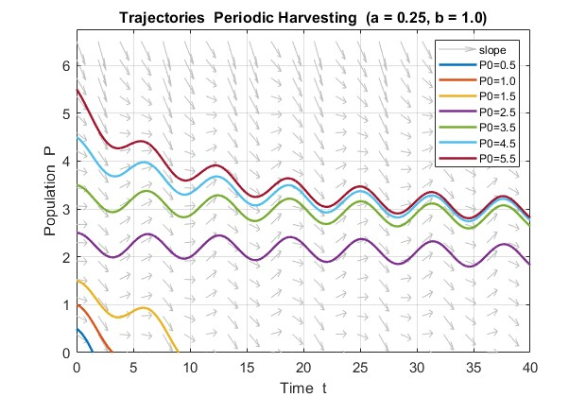
Fig 3.9 — Trajectories for Periodic Harvesting (a = a₂ = 0.25)
At a = 0.21 the oscillating trajectories stabilize around a sustained mean level. At a = 0.25 the trajectories oscillate but the mean level drifts downward with each successive cycle. The low initial conditions P0 = 0.5 and P0 = 1.0 reach extinction faster than in the a = 0.21 case. This progressive decline under a = 0.25 demonstrates that setting the periodic harvesting rate equal to the constant model MSY is already unsustainable in practice.

3.3.6 Effect of Parameter b
To investigate how harvesting frequency affects population dynamics, the parameter b is varied while keeping all other parameters fixed at k = 0.20, N = 5, a = 0.21, and P0 = 4.0.
Effect of Frequency b (b = 0.5, 1, 2, 4)

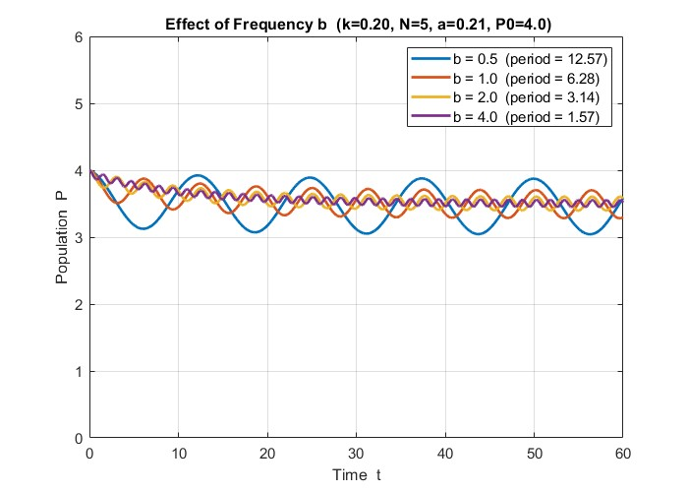Fig 3.10 — Trajectories for Varying b (b = 0.5, 1, 2, 4)
The figure shows all four trajectories plotted together on the same axes, allowing direct comparison of the effect of harvesting frequency on population dynamics for the same initial condition P0 = 4.0 and the same average harvesting rate a = 0.21.

3.4 Comparison and Sensitivity Analysis
3.4.1 Constant vs Periodic
To directly compare the two harvesting models, both are simulated using identical parameter values: k = 0.20, N = 5, a = 0.21, b = 1.0, and P0 = 4.0. The only difference between the two simulations is the form of the harvesting term — constant a versus periodic a(1 + sin(bt)).
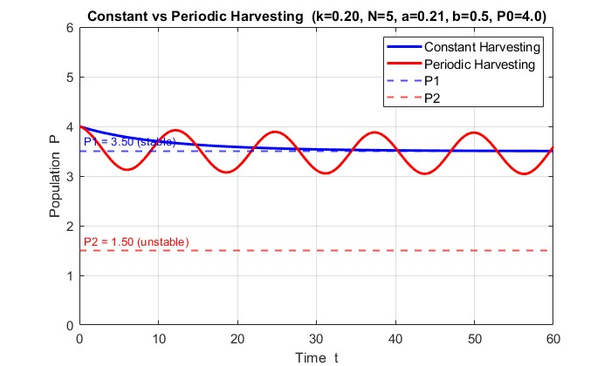
Fig 3.11 — Constant vs Periodic Harvesting
The side-by-side comparison reveals a fundamental difference in long-term population behavior between the two models. Under constant harvesting the population follows a smooth monotonic trajectory that converges to the stable equilibrium P₁ = 3.5 and remains there indefinitely. The population settles into a fixed steady state with no further fluctuation. Under periodic harvesting with the same average harvesting rate a = 0.21, the population never reaches a fixed steady state. Instead, it oscillates continuously in response to the sinusoidal harvesting cycle, rising during low-harvest phases and declining during peak-harvest phases.

3.4.2 Which Model is More Realistic
From a biological and management perspective, the periodic harvesting model is more realistic than the constant harvesting model for the following reasons.
Real fisheries do not operate year-round at a fixed rate. Fishing is governed by seasonal regulations, weather patterns, and migration cycles — grounds are opened and closed throughout the year. The sinusoidal function a (1 + sin(bt)) captures this cycle naturally. In contrast the constant model a certain number units are removed per unit time regardless of actual population size, which is biologically impossible when fish are scarce.
Furthermore, real fish populations do not sit at a fixed equilibrium. They fluctuate in response to environmental variability and seasonal productivity changes. The oscillating trajectories of the periodic model are conceptually closer to what is observed in real fishery data than the smooth convergence of the constant model.
However, the periodic model also has limitations — a perfect sinusoidal harvesting pattern is still a simplification of irregular real-world fishing activity. Despite this, the periodic model provides a substantially more realistic framework for guiding fishery management decisions and should be preferred as the primary planning tool, with the constant model used as a theoretical reference.

3.4.3 Effect of Growth Rate k
The intrinsic growth rate k represents how rapidly the fish population reproduces under ideal conditions. To isolate its effect, N = 5 and a = 0.21 are held fixed while k is varied across the values 0.10, 0.20, 0.30, and 0.40.
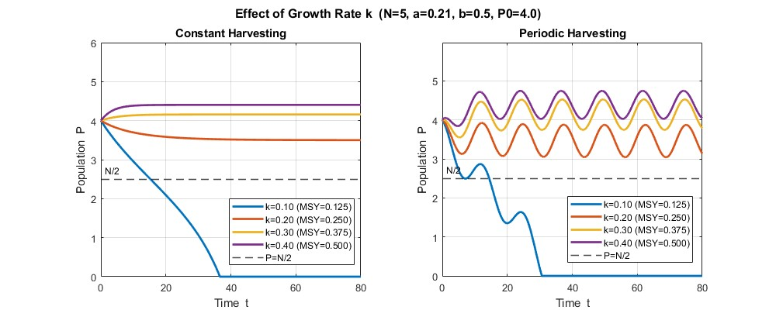
Fig 3.12 — Effect of Varying k on Population Trajectories
As k increases, the MSY (= kN/4) increases proportionally, allowing the population to sustain higher harvesting pressure. At k = 0.10, the MSY of 0.125 falls below a = 0.21, driving the population to extinction under both harvesting modes. For k ≥ 0.20, the population stabilizes at a higher P₁ as k increases. Under periodic harvesting, surviving populations oscillate around mean values that closely match the constant-harvesting equilibria, confirming that the constant model reliably predicts long-run average behavior.

The sensitivity of the equilibrium points to k is summarized below:
Effect of Growth Rate k (N = 5, a = 0.21)
k | MSY = kN/4 | P₁ (constant) | P₂ (constant) | Status (constant) | Mean P (periodic)
0.10 | 0.1250 | — | — | Extinction | Extinction
0.20 | 0.2500 | 3.5000 | 1.5000 | Sustainable | 3.50
0.30 | 0.3750 | 4.1583 | 0.8417 | Sustainable | 4.16
0.40 | 0.5000 | 4.4039 | 0.5961 | Sustainable | 4.40
Table 3.2 — Effect of Growth Rate

3.4.4 Effect of Carrying Capacity N
The carrying capacity N represents the maximum population size the environment can support. To isolate its effect, k = 0.20 and a = 0.21 are held fixed while N is varied across the values 3, 5, 7, and 10.
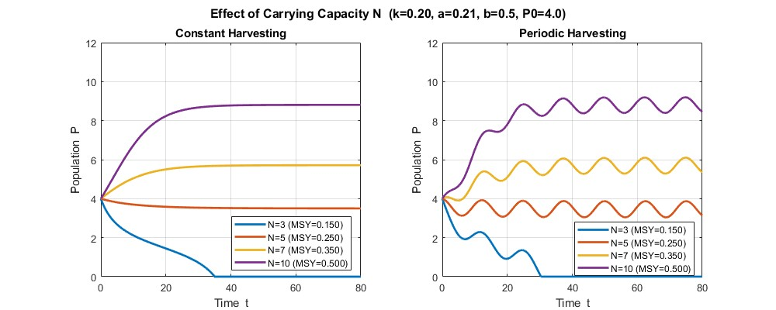
Fig 3.13 — Effect of Varying N on Population Trajectories

Effect of Carrying Capacity N (k = 0.20, a = 0.21)
N | MSY = kN/4 | P₁ (constant) | P₂ (constant) | Status (constant) | Mean P (periodic)
3 | 0.1500 | — | — | Extinction | Extinction
5 | 0.2500 | 3.5000 | 1.5000 | Sustainable | 3.50
7 | 0.3500 | 5.7136 | 1.2864 | Sustainable | 5.72
10 | 0.5000 | 8.8079 | 1.1921 | Sustainable | 8.82
Table 3.3 — Effect of Carrying Capacity N
3.4.5 Effect of Harvesting Rate a
To examine how increasing the harvesting rate drives the system toward extinction, k = 0.20, N = 5, b = 1.0, and P0 = 4.0 are held fixed while a is increased across six values: 0.05, 0.10, 0.15, 0.21, 0.25, and 0.30.
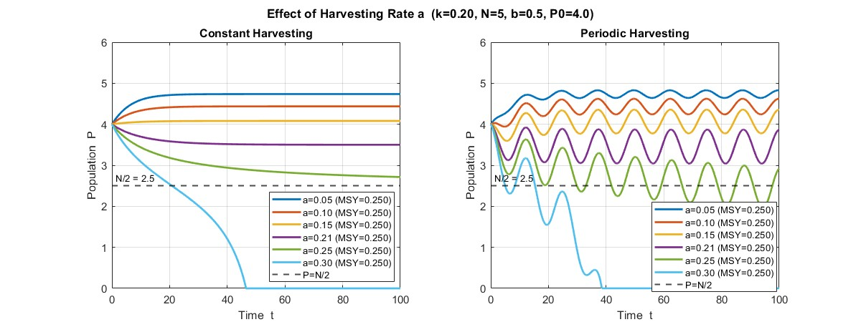
Fig 3.14 — Effect of Harvesting Rate a
Both harvesting models share the same collapse threshold at a = 0.25, but behave differently near it. Under constant harvesting, populations converge smoothly to stable equilibria, while periodic harvesting produces lower mean populations with increasing oscillations as a approaches the MSY. When a exceeds 0.25, both models collapse to extinction, but periodic harvesting collapses more abruptly due to the additional stress of peak harvesting episodes.

Chapter 4
Conclusion
This project explored how mathematical modelling can be used to understand bacterial infections, antibiotic resistance, and the role of the immune system. By developing and analyzing a system of differential equations, we were able to capture the complex interactions between sensitive bacteria, resistant bacteria, and immune response.
The study shows that the outcome of an infection depends strongly on the balance between bacterial growth, antibiotic effectiveness, and immune strength. In some cases, treatment can eliminate sensitive bacteria but still allow resistant strains to persist, while in others, both types of bacteria may continue to survive. Overall, the model highlights a key real-world insight: antibiotic treatment alone is not always sufficient—an effective immune response is equally important in controlling infections. This emphasizes the growing challenge of antibiotic resistance in modern healthcare.
In conclusion, mathematical models like this provide valuable tools for predicting infection behavior and can support better treatment strategies, while also pointing to the need for continued research in combating antibiotic resistance.

For the population model, logistic growth with harvesting showed that sustainability is highly dependent on the harvesting rate. A critical threshold exists, beyond which the population declines rapidly and may approach extinction, as observed near the limiting value of the harvesting parameter. Periodic harvesting, while more complex, provides a more realistic representation and can help regulate populations when applied appropriately. Numerical simulations and graphical methods further supported the analytical results by illustrating system behavior over time. Together, these models emphasize a common insight: maintaining balance within a system is essential for long-term stability.
In conclusion, this project highlights the power of differential equations as practical tools for modelling, prediction, and decision-making in biological and ecological systems, while also emphasizing the need for careful parameter control to ensure sustainable outcomes.

References
- Mondragón E.I., Mosquera S., Cerón M., et al.- Mathematical Modeling on Bacterial Resistance to Multiple Antibiotics Caused by Spontaneous Mutations. BioSystems, 2014.
- Pugliese A. and Gandolfi A.- A Simple Model of Pathogen–Immune Dynamics Including Specific and Non-Specific Immunity. Mathematical Biosciences, 2008.
- Alavez J., Avendaño R., Esteva L., et al.- Within-Host Population Dynamics of Antibiotic-Resistant M. tuberculosis. Mathematical Medicine and Biology, 2006.
- Hethcote H.W.- The Mathematics of Infectious Diseases. SIAM Review, 2000.
- Nowak M.A. and May R.- Virus Dynamics: Mathematical Principles of Immunology and Virology. Oxford University Press, 2000.
- Bonhoeffer S., Lipsitch M. and Levin B.R.- Evaluating Treatment Protocols to Prevent Antibiotic Resistance. Proceedings of the National Academy of Sciences USA, 1997.
- Blanchard, P., Devaney, R.L., Hall, G.R. (2012) - Differential Equations, 4th Ed. Boston, USA: Brooks/Cole, Cengage Learning.
- Idels, L.V. & Wang, M. 2008 - Harvesting fisheries management strategies with modified effort function. International Journal Modelling, Identification and Control 3: 83-87
- Jing, W. & Ke, W. 2004a - Optimal control of harvesting for single population. Applied Mathematics and Computation 156: 235-247
- Jing, W. & Ke, W. 2004b - The optimal harvesting problems of a stage-structured population. Applied Mathematics and Computation /
- John, W., Pamela, M. & Eric, T. 2005 - The relationship of fish harvesting capacity to excess capacity and overcapacity. Marine Resource Economics 19: 525-529.
- Li, W. & Wang, K. 2010 - Optimal harvesting policy for general stochastic logistic population model. Journal of Mathematical Analysis and Applications 368: 420-428
- Ludwig, D. 2001 - A theory of sustainable harvesting. SIAM. J. On Appl. Math. 55: 564-575.

